Instructions for compiling ISOmodel using Visual Studio 2022 / VS 2022 community edition

If you plan to work from the publicly available, open source, ISOmodel git repository and keep your changes/additions open source, the terms of use allow use of VS 2022 community edition even if you are a commercial business or enterprise. If you are a commercial company and plan on keeping those changes within your company or releasing in closed source software, you cannot use VS 2022 community edition and must have a licensed version VS 2022 Pro.

In the setup process it’s best to install CMake first so that the Visual Studio environment can find CMake during its own install.

Install CMake >=3.20
https://github.com/Kitware/CMake/releases/download/v4.0.1/cmake-4.0.1-windows-x86_64.msi
Install with the option “Add CMake to the PATH environment variable” checked.
This will prompt for admin login

Download VS 2022/ VS 2022 Community Edition and begin installing
Select Desktop development with C++ and use default settings. You might want to uncheck GitHub Copilot if you don’t want more Copilot stuff. Here is what my install looks like with GitHub Copilot unchecked.

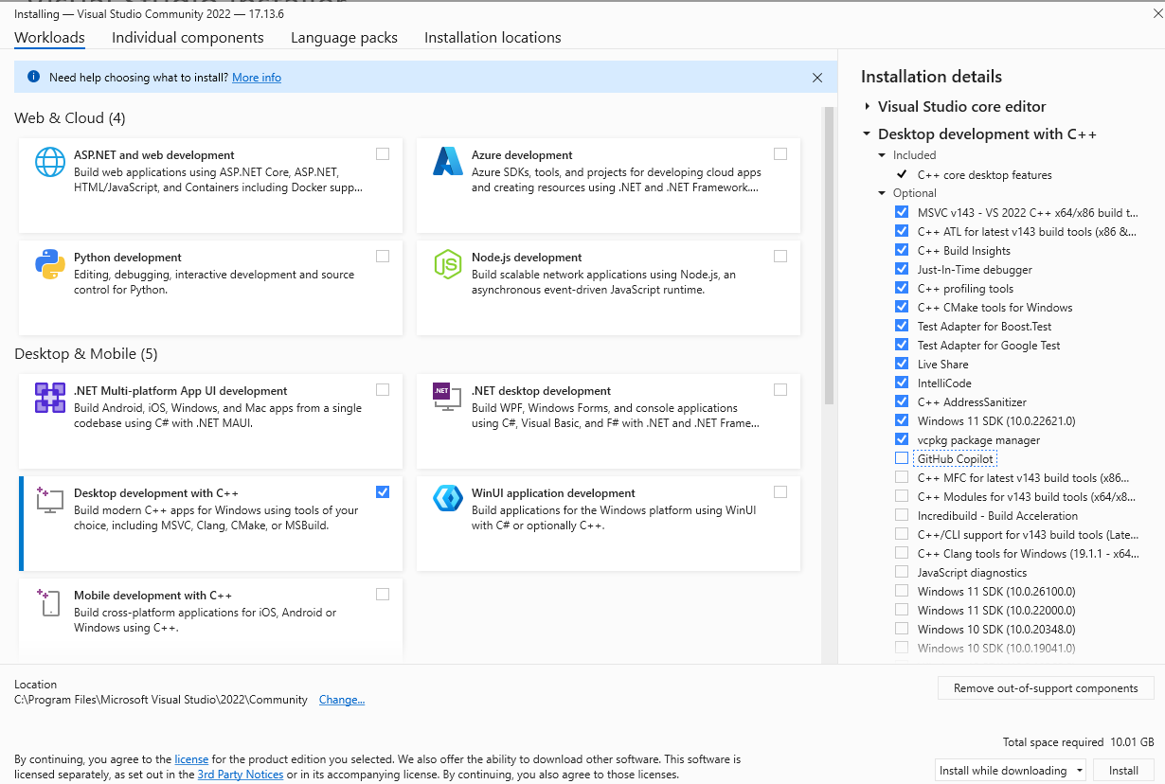

Creating the using Visual Studio IDE Project files

First we need to create the .sln files
Open a command line and go to the isomodel directory root (e.g. c:\git\isomodel\isomodel\) and make a binary directory

cd C:\git\idomodel\isomodel
mkdir bin
cd bin

Now you use cmake to create

cmake ../src

If things are working the output should look something like this:

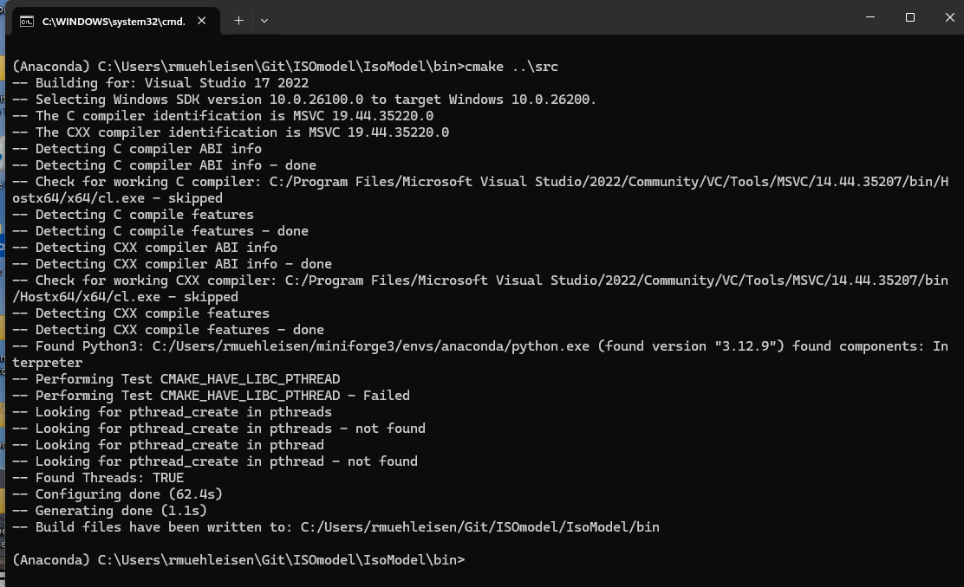

This process will have created a CMakeFiles directory and a bunch of other visual studio project files in the bin directory including “isomodel_project.sln”. My directory looks like the following

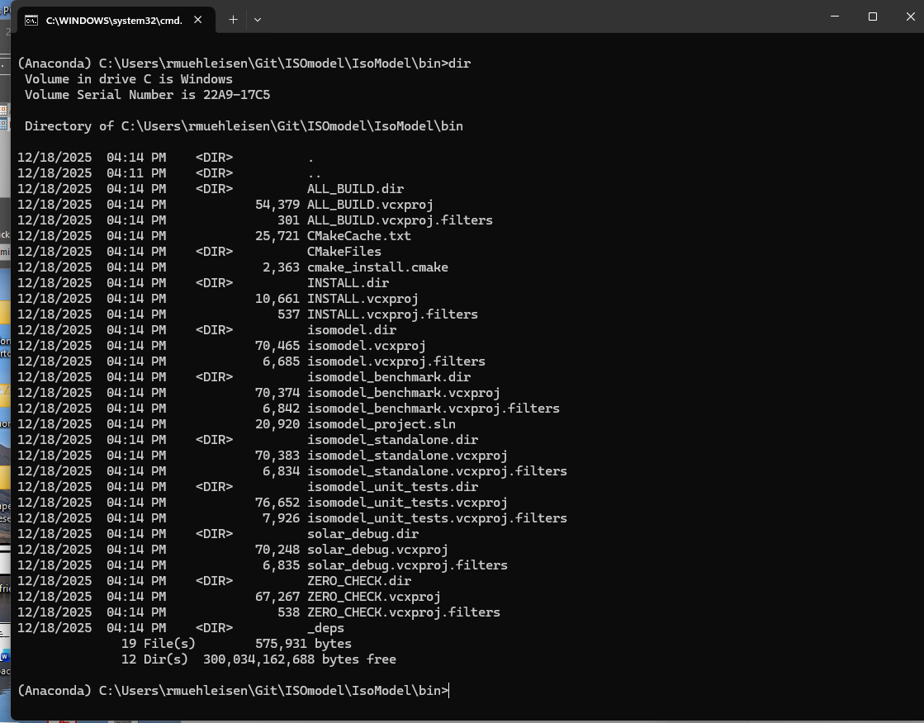

Load isomodel_project.sln into Visual Studio and change build to Release, x64 and build the entire project. You can do that by double clicking isomodel_project.sln from windows explorer.

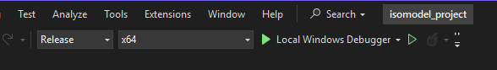

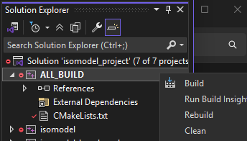

This will crunch for a while , give you some warnings, and then complete. This full build will build some yaml tools and the google test library before the actual isomodel projects so it can take a while. You can speed up future compilation for individual projects by selecting the “Project Only” build options when you right click. Anyhow, and some errors, but hopefully you will get through it and the bottom of the output should look something like this:

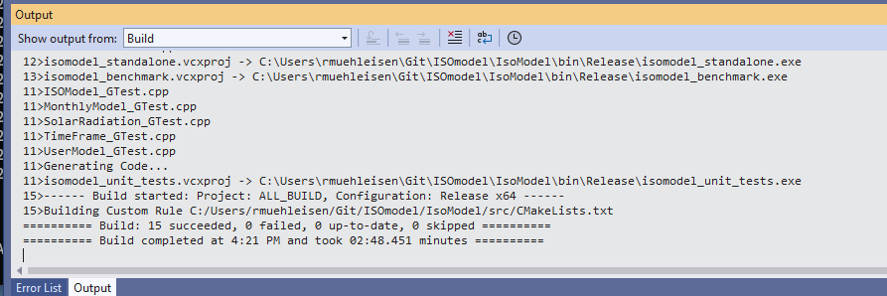

The compiled programs will be in the bin\Release subdirectory

Testing the Build.
If the isomodel_unit_tests build succeeded, you should be able to run the unit tests and confirm your compile worked right

cd Release
isomodel_unit_tests.exe

When I run the output looks like this:

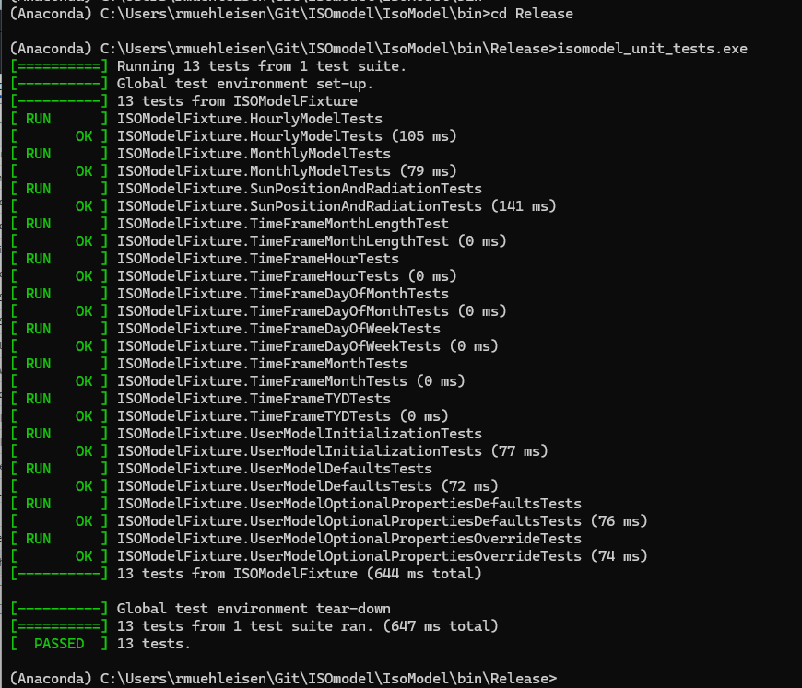

You should also test the isomodel_standalone. To do that you will need to get a building yaml file and weather file. You can copy test_bldg.yaml and test.epw files to the release directory with the command and run the isomodel standalone with the commands

cp ..\..\test_data\test* .
isomodel_standalone.exe -h -i test_bldg.yaml

You should get something like the following out
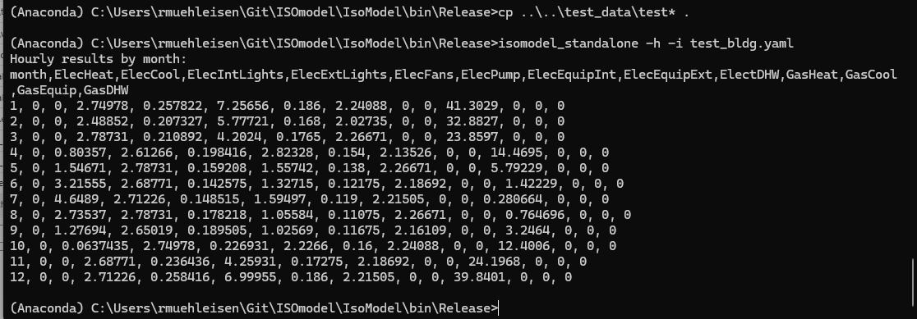

That’s it! Good job!

